**Football Club Management System Database Design Document**

1. **Introduction**

This document outlines the database design for a Football Club Management System, which aims to offer an integrated data management solution for football club operations. The system focuses on player and team management, performance analysis, market value tracking, contract and transfer management, and insights into financials related to the football transfer market. The objective is to provide efficient and streamlined processes to help clubs manage player transactions, evaluate player performance, and make informed decisions during transfer windows.

1. **Business Problems Addressed**
2. **Player Management**: Capturing and maintaining detailed player information, including personal, physical, and career data.
3. **Contract Administration**: Managing player contract details and their relationships with agents to ensure smooth negotiations and agreements.
4. **Transfer Monitoring**: Tracking player movements between clubs and managing the financial details of transfers, such as fees and dates.
5. **Performance Evaluation**: Recording and analyzing player performance metrics, including statistics like goals, assists, and disciplinary records.
6. **Market Value Tracking**: Monitoring fluctuations in players' market values across different seasons to aid in decision-making.
7. **Club and League Organization**: Structuring the relationships between players, clubs, and leagues to ensure accurate representation and management.
8. **Scouting Reports**: Allowing scouts to evaluate players and provide structured feedback for recruitment and development.

**3. Entities Description**

1. Players

* Represents individual football players, storing key personal and career-related information. It serves as the central entity for managing player details and relationships with other entities such as clubs, contracts, and performance stats.

2. Agent

* Represents agents who manage players' professional careers, particularly during contract negotiations and transfers. It connects to the Contract entity to establish which agent represents which player.

3. Contract

* Captures details of the contractual agreements between players and clubs, including terms and conditions. It links players with their agents and manages information related to the duration of their contract with a club.

4. Transfer

* Tracks the movement of players between different clubs. This entity records the history of player transfers and the financial details involved in each transfer.

5. Stats

* Stores detailed player performance data, including various metrics like appearances, goals, and other key statistics. It is connected to the Players entity and is crucial for performance evaluation.

6. Club

* Represents football clubs that players belong to. This entity is connected to Players, Transfers, and League, facilitating the organization of teams within different leagues and the management of club-specific data like stadium details.

7. League

* Represents football leagues to which clubs belong. It organizes clubs within a competition framework and is crucial for defining the relationship between clubs and their respective leagues.

8. MarketValue

* Tracks the market value of players over different seasons. It is linked to both Players and Season Info entities to help assess a player’s financial worth over time.

9. Season Info

* Stores data related to specific football seasons, including squad composition and aggregate statistics. It links players, clubs, and leagues during a specific season to track performance and market conditions.

10. ScoutingReport

* Represents reports created by scouts, evaluating players based on observations during different seasons. It connects scouts to players and provides feedback that helps clubs make informed recruitment decisions.

11. Scout

* Represents scouts who evaluate and provide reports on players. This entity is related to ScoutingReport, allowing clubs to track player evaluations over time.

12. Season

* Represents different football seasons, organizing data related to clubs, players, and performance metrics for a specific time period.

**4. Entity Relationships**

**1. Players - Agent (One-to-Many)**

This relationship captures the fact that an agent represents several players, but each player has only one primary agent responsible for their contracts and negotiations.

**2. Players - Contract (One-to-One)**

A player can only have one active contract with a club at a given time, while a contract cannot exist without being associated with a player.

**3. Contract - Agent (Many-to-One)**

This relationship reflects that agents are responsible for handling contracts for multiple players, but each contract involves only one agent.

**4. Players - Transfer (One-to-Many)**

Players can be transferred multiple times during their careers, and each transfer represents the movement of one player between clubs.

**5. Players - Stats (One-to-Many)**

This relationship allows the recording of performance metrics for players over time, with each stat record corresponding to a single player's performance.

**6. Players - MarketValue (One-to-Many)**

A player’s market value can fluctuate over time, and this relationship tracks those changes season by season.

**7. Players - ScoutingReport (One-to-Many)**

Scouts can evaluate players multiple times over their careers, and each scouting report focuses on a specific player.

**8. Players - Club (Many-to-One)**

Players are members of clubs, and clubs house multiple players. This relationship defines which players are currently part of a specific club.

**9. Club - League (Many-to-One)**

Football clubs compete within leagues, and each league consists of several clubs.

**10. Club - Season Info (One-to-Many)**

This relationship captures club participation and performance data across multiple seasons, allowing for season-specific club information.

**11. League - Season Info (One-to-Many)**

This relationship shows how leagues host multiple clubs in different seasons, linking a league to its seasonal structure.

**12. Season - Season Info (One-to-Many)**

This relationship links a specific season to the performance and structural data (like average squad age, market value) for that season.

**13. ScoutingReport - Scout (Many-to-One)**

Scouts evaluate multiple players across different seasons, and each report is linked back to the scout who created it.

**14. Season Info - MarketValue (One-to-Many)**

This relationship tracks how player market values are recorded in relation to a specific season's information.

**15. Season Info - ScoutingReport (One-to-Many)**

Each season can have multiple scouting reports, linking individual player evaluations to a specific season.

**5. ER Diagram**

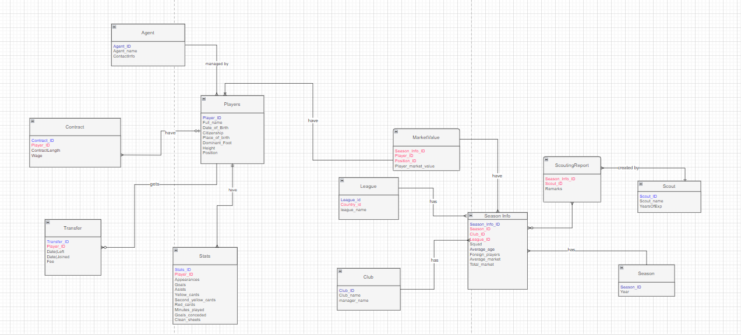

Primary Key  
Foreign Key